**Sprint 1: Final Project Requirements Analysis**

**Need:** A method of analysing message toxicity to adapt OSS.

**Purpose:** To enable open source projects and their communities to apply feedback and improve project health, efficiency, and quality by utilizing related metrics (i.e. data points, graphs, visualized patterns, etc.) on message toxicity through a system.

**Client Base:** OSS Community -- Open source software projects, businesses, contributors, and maintainers

**Process:**

**Data Aggregation**

Pull data from Augur community Reports and augur_vmware and augur_czi databases

Repo ID

Repo Name

Message Count

Message Time

Message Month

Issue Message Count

**From Augur to Jupyter Notebook**

Transfer data from Augur Community Reports and Database Queries into Jupyter Notebooks for Analysis and Graph Manipulation

**From Jupyter Notebooks To Graphical Data Representation**

In the Jupyter Notebook Pages write up the data and port it into the appropriate graphical output. These outputs include the following graph metrics:

* Toxic Messages Per User (Distributed)
* Toxic Messages Over Time (Lifetime of the Project)
* Toxic Messages By User and Users Project Contribution Lifetime
* Toxic Messages Count By User versus Total Message Count By User

Users of the Jupyter Notebook Pages will be able to view the pages contents and alter variables to calculate Toxicity Reports for Repos that they wish to query

The output of the Jupyter Pages will be the graphical data representations of the Repo Toxicity Metrics listed above.

**Use Case:**

* **Title:** Evaluating Open Source Project Toxicity
* **Description:** A manager wishes to check the status and value of an open source project before using it in a project. The manager wishes to ensure that the project development is one that is collaborative and reflects the values of his project. The manager wishes to query the prospective project's repo for toxicity before taking on its image and values in his project.
* **Triggers:** Actor runs Jupyter Notebook Pages
* **Actors:** Project Manager, Project team members
* **Preconditions:** Manager has a project repository in mind they wish to query and they meet the systems requirements below which include network connection and access to the github repo for augur, access to the Augur Community Reports tool, access to the augur_vmware and augur_czi databases
* **Main Success Scenario:** The project and jupyter pages compile for the user and the graphical data representations of repo toxicity are generated and presented to the user.
* **Failed End Condition:** The reports and graphics do not compile and present themselves to the user
* **Diagram:**

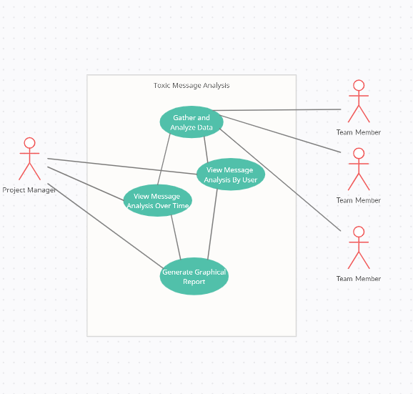

**System Constraints/Requirements**

* Network connection to Augur github
* Network connection and access to Augur Community Reports
* Access to augur_vmware and augur_czi databases